**2023**

*C:\Users\Richard Erhiawarien\Documents\My Data\!Adonai Partners\Logo\Adonai Partners Logo\Logo\adonaipartners_logo.eps*

1047 Caitlin Court,

Silver Spring, MD 20904 USA

Toll Free: (800) 334-2775

**mail@adonaipartners.org**

**www.adonaipartners.org**

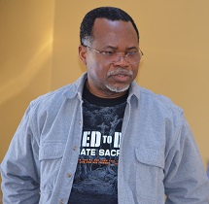

**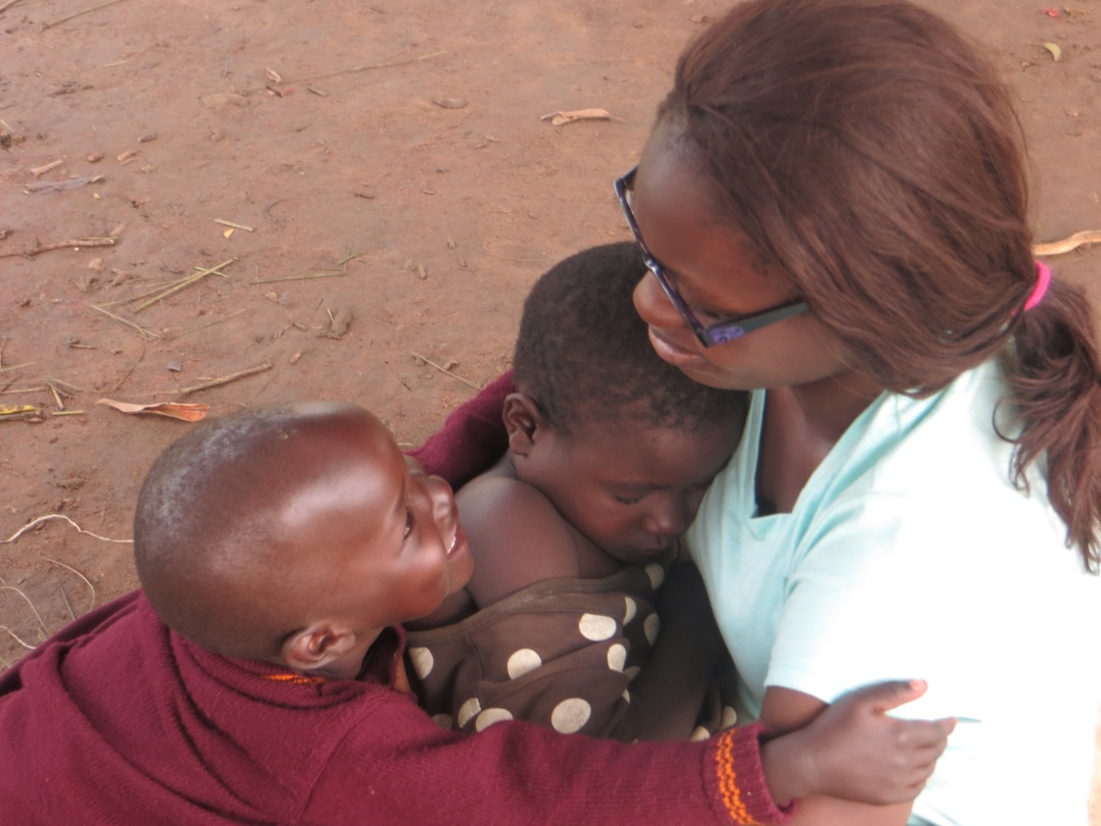**

Short Term Mission Trip

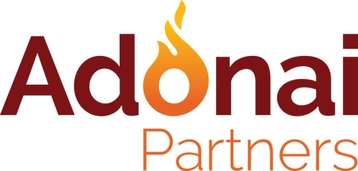

…mobilizing Africans and others to transform Africa for Christ

*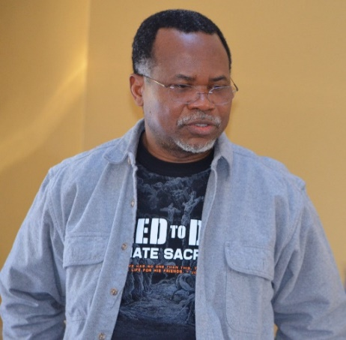*Dear Team Member,

I would like to thank you personally for registering for our short term mission trip and to extend a very warm welcome to you in the precious name of our Lord Jesus Christ. We are excited to have you as part of the Adonai family. Let me remind you right from the start that this is more than a trip! Being a part of the Adonai family, is a lifestyle that our Lord has called us all into. As you probably know already, through God’s grace we have been carrying out mission trips in different countries since Adonai Partners was founded in 2006. Each year we have seen the faithfulness of God - His love, power and grace at work. We do short-term mission trips with a long-term perspective, seeking to build lasting relationships that result in transformation both in the communities where we work as well as in the lives of our team members. That’s you! So be expectant! You are a part of His Story!

I believe your decision to be on this mission will bring you closer to our Lord Jesus Christ. You are part of a community seeking to love God passionately by loving those He loves so dearly and cares for so deeply. Together, we serve Him by serving the poor. You will have an opportunity to grow in your faith and to be an instrument of His grace in the lives of others. Please read through this **document** carefully; follow the guidance provided and take action where required.

If you have any questions, please do not hesitate to let me know. I’m just an email away!

**Adonai Partners, where love takes action!**

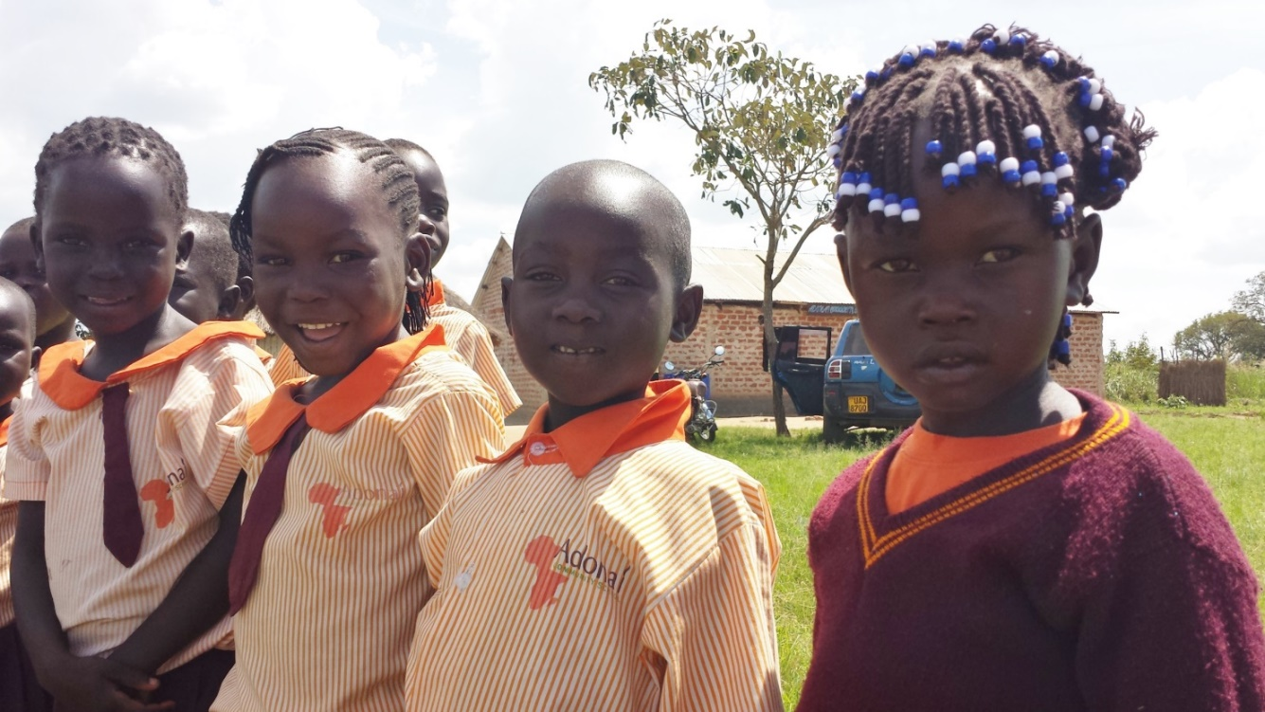Richard Erhiawarien

President

**Table of Contents**

|  |  |
| --- | --- |
|  | *Page* |
| 1. *Welcome to the Adonai Mission Team* | *1* |
| 1. *Following Jesus’ example* | *2* |
| 1. *Embrace a vision for the poor* | *3* |
| 1. *Set specific personal goals* | *4* |
| 1. *Trip Locations and Dates* | *4* |
| 1. *YoungLIFE* | *5* |
| 1. *Team Training* | *5* |
| 1. *Fund Raising* | *5* |
| 1. *Passports, visas, immunizations and insurance* | *7* |
| 1. *Spiritual Preparation* | *7* |
| 1. *Ministry Assignments* | *8* |
| 1. *Trip Cost* | *8* |
| 1. *Ministry Programs* | *9* |
| 1. *Ten Team Commitments* | *9* |
| 1. *Trip Reports* | *11* |
| 1. *Staying Engaged* | *11* |

**Following Jesus’ Example+**

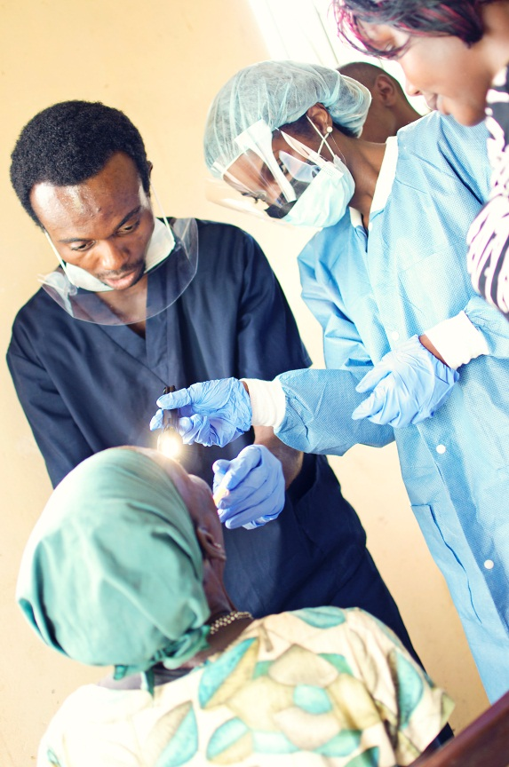Our Lord Jesus drew large crowds wherever He went. Yet again and again, He stopped to touch that one person who needed to experience His love and forgiveness. Some of these are Zacchaeus, Mary Magdalene, Bartimaeus and Thomas. He frequently addressed multitudes but called individuals to come follow Him. Whether it was walking all day on the dusty roads of rural Galilee, going without food or water, staying up all night teaching and praying, Jesus sacrificed much to minister to the needs of people. He washed the feet of His disciples. He taught about the Kingdom, gave words of eternal life to the crowd that followed Him, but also provided real fish and bread to thousands who were hungry. When He gave up His own life and died on the cross for those who barely knew Him or deserved it, He demonstrated ultimate sacrificial love through personal action beyond words. He passed on this legacy of sacrificial love to His followers when He commanded us to love one another and that “… *whatever you did for one of the least of these brothers of mine, you did for me*.” (Matt 25:40). And this was exactly what the early Christians did. In the first century, at a huge risk to their own lives, His followers sacrificed to show His love. When the first believers decided to follow Christ, they knew it meant a lifestyle of sacrificial love. In Adonai Partners, we see this as our heritage! We’re called to walk in His steps.

*Dr. Ambrose Obhade with our dental team in Uganda*

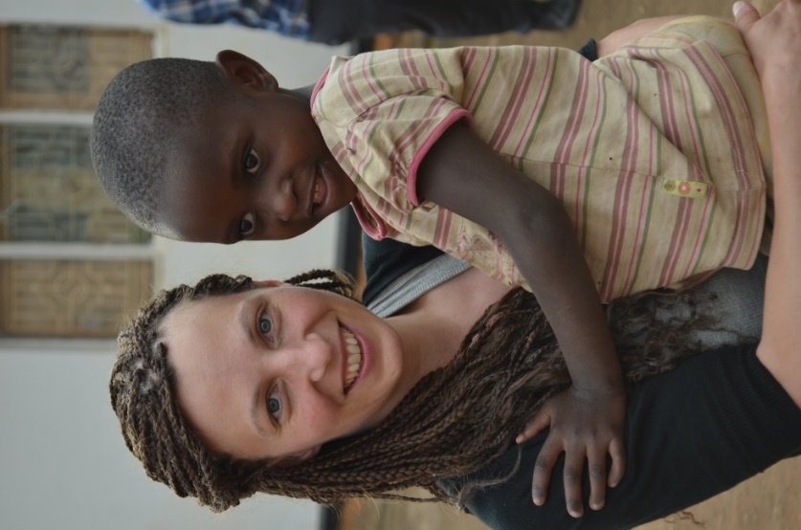We are committed to proclaiming the message of our Lord Jesus by words of hope and deeds of compassion. On this mission, you will have an opportunity to take up the legacy of Jesus’ love and serve vulnerable people. You will be part of a diverse team proclaiming the love of Jesus by word and deed! Begin now to pray for that one individual in whose *.*life you will make all the difference during this mission. You’ve got only one life to live, make it count!

We have several programs designed to improve the lives of the poor, unreached and vulnerable during the trip. There’ll be medical and children education programs. We may feed children and equip them with life skills. We will have community programs, especially those targeting youths and women. There will also be a discipleship training for local leaders and team members. All of these programs, which differ from one location to the other, have a single purpose: community transformation, one person at a time!

*Team member, Andrea encouraging a child in Uganda*

### **Embrace a vision for the poor\***

For most of us, caring for the poor is an after-thought. We are not unconcerned, we’re just not intentional in our efforts. For God, caring for the poor is not an after-thought. It is His character, who He is. It is an emphatic theme in His Word. It is written into His Law, it is expressed in His wisdom, it is measured by the prophets, it is characteristic of Jesus’ life and teaching, and it is a substantial ministry in the New Testament Church. From cover to cover, the Bible tells us of God’s concern for the poor.

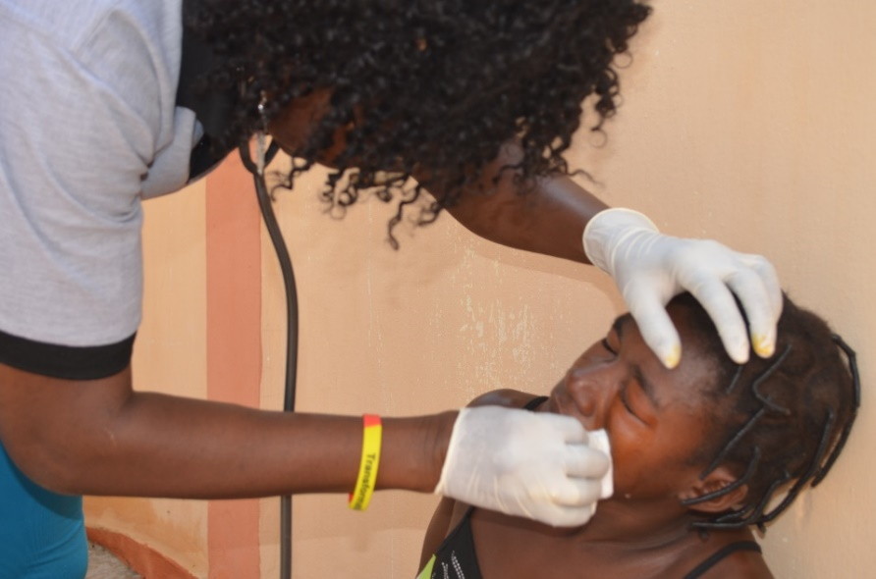Modern Christianity maintains ministries for the poor, but these are often just peripheral ministries. For most Christians, our efforts include donating things we no longer value and expecting our denominations to help the needy. But God is a hands-on God, and we are to be hands-on people. According to Proverbs 14:31, our view of the needy reflects our view of God. Do we see in them the image of God? Our love for God will determine how we treat other people – even the least of them. This mission trip will give you an opportunity to show kindness to those who need it most.

*Team member, Dr. Flore Assah attending to a patient in northern Togo*

**Set Specific Personal Goals**

To get the most benefit from your participation in this mission trip, spiritual preparation is essential. We encourage you to set specific spiritual goals for yourself. **In addition, write your story and how you came to know that this was what God wanted you to do**. If possible, maintain a journal to capture every important moment leading to the trip, during the trip and thereafter, noting what God is doing in your life. From our experience, the mission trip is more for you than for the people you will be serving in the field! The long-term benefits are limitless, here are some of the opportunities:

* 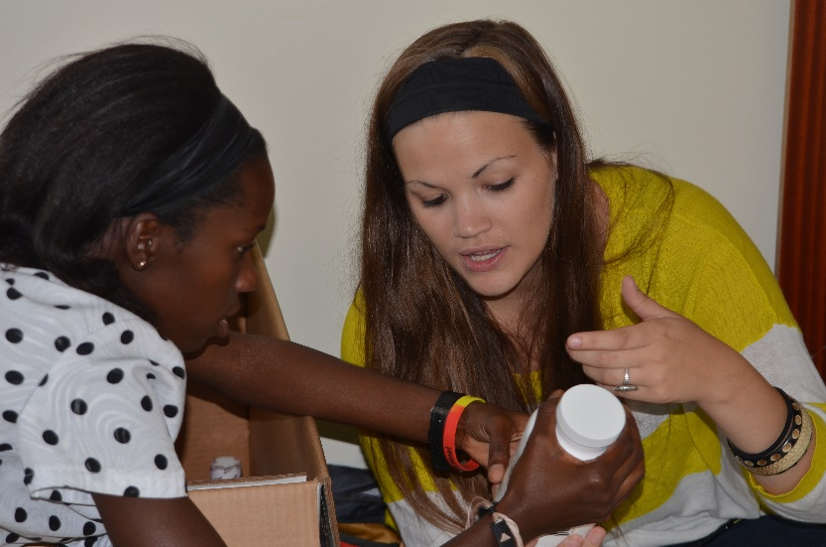*You will become a better disciple of Jesus Christ with a global perspective;*
* *You will grow spiritually with a deeper love for God and compassion for the poor;*
* *You will gain a better insight into God’s love for a hurting world and His compassion for the poor, the vulnerable and unreached;*
* *You will exercise your professional skills and spiritual gifts in ways you may never have done before;*

*Nurses, Sylvia & Johnna, checking out medications*

* *You will get a deeper understanding of what missions is all about and your place in God’s plan to reveal His love to people trapped in a vicious circle of extreme poverty;*
* *You will return home with a passion to be an advocate for the poor and to serve God with Adonai Partners – increasing your involvement in missions through prayers and financial support or return to continue the work and grow in your experience and impact; and*
* *Ultimately, you will embrace a mission life-style looking for opportunities to remain engaged in what God is doing and actively serve Him through wherever you can.*

Therefore, we encourage you to **carefully write down your personal goals for this trip**. Also, please plan to share your experience with your family, friends, church family and those you work with. There will also be opportunities to share what the trip meant to you at an Adonai Partners event such as **Oasis**, **Ignite** or **Barnabas Gathering**. Team members are encouraged to re-visit their personal goals to see what great things our faithful God has done for us during the trip.

**Trip Locations and Dates**

Trip locations and dates have been planned well in advance. However, due to unavoidable circumstances or ticketing constraints these could change. You will be promptly informed should that happen. The trips we have planned for 2023 will take place in the following countries: **Nigeria, Togo,** **Ghana,** and **Uganda.** The dates for these trips are usually published on our website and Social Media.

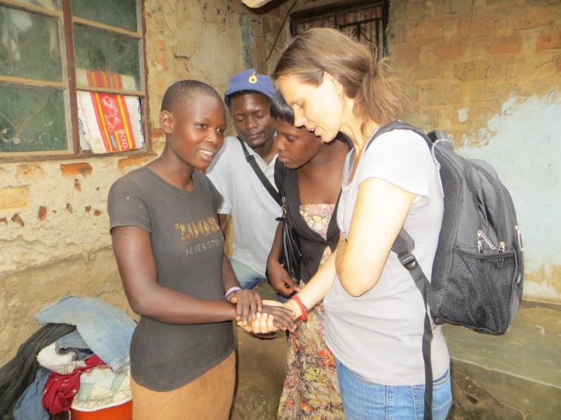**YoungLIFE**

We live in very turbulent times today. But God calls His people to respond with love and compassion. In every generation, authentic Christianity has always been to care for the poor and the weak – especially orphans and widows in their distress! Adonai Partners has been positioned to be God’s hand extended to touch the world - it’s poor, ignored and vulnerable.

We have chosen to engage our world! Beyond words, we are proclaiming the life-changing message of Christ by compassionate action among those who do not have an opportunity to hear the Good News. We are committed to holistic transformation in communities. We are very intentional and are committed to young people. And this is what the YoungLIFE Café is all about.

*Team member, Birgit ministering to youth in Uganda*

We all know that children are often the most affected victims in any social unrest. Yet, not much attention is directed at addressing the needs of these children. In Adonai Partners, we see ministry to children as strategic to taking God’s love to a hurting world. Jesus said, “Let the children come to me. Don’t stop them, for the Kingdom of God belongs to those who are like these children.” [Luke 18: 16 NLT]. This is exactly what our teams do during the mission as we minister to and feed hundreds of vulnerable children every year.

**Team Training**

Adonai Partners takes training and spiritual preparation seriously; therefore, the training sessions are mandatory. The training helps us to strengthen the team and prevent problems common to short term mission trips. The goal is to equip every team member for fruitful ministry, have a rich experience and to build a community of people who are passionate for God’s purpose in the nations. Besides providing an opportunity for worship, prayer and fellowship, the training sessions cover a broad range of topics, including God’s global purpose and His heart for the nations, cultural sensitivity, team building, missionary advocacy, spiritual preparation, fundraising, ministry responsibilities, spiritual warfare, etc. We will answer your questions, discuss travel arrangements and also cover such practical issues as the [**Adonai Code**](https://www.adonaipartners.org/post/the-adonai-code). Please make sure you attend the training and preparation meetings organized for team members. Training may include face-to-face sessions or Zoom video conference. Please find out about the training schedule and take advantage of them.

### **Fund Raising**

Fund raising is an important topic, yet it is one that most people are unfamiliar with. Although no one who is called to this mission would be held back by lack of money, each team member should understand that they are responsible for the trip cost – particularly travel, room and board. Therefore, we encourage you to actively engage in fund raising for the trip, and do so with the confidence that God is our Source and He is faithful. There are different approaches to fund raising for missions. The easiest approach is to reach within your own purse if you already have set aside funds for the trip. However, that is very unlikely, so we encourage everyone to do fundraising. Besides, raising money is not the only objective of fundraising. The fund raising process allows us to grow in humility and faith as we pray and trust God to provide the resources needed to accomplish His purposes, remembering that He not only calls us, but also equips and sends us (Luke 10:2).

In addition, fund raising allows us to share with others about Christ's love for the poor and unreached, your own passion for God and Adonai Partners’ work. Fund raising provides an opportunity for more people to partner with us in this ministry; remembering that though Jesus calls us all to participate in the Great Commission, we don't all function in the same way. Some are called to be senders and pray for mission trips and missionaries, while others, such as you, have the opportunity to go.

### G:\Jennifer Price Portfolio\Charles4.jpgBelow are a few guidelines to keep in mind as you begin your fund raising today:

* The first step is to develop a succinct statement of your vision for the mission trip to share with your sponsors. From our experience, people are more likely to invest in a vision – what God is doing in your life, than to merely make a donation. Ask God to help you articulate what God wants to do through you during this mission.
  + Secondly look for ways to share your vision, your story and love for Christ and the people we will be serving during the mission.
  + Prayerfully consider who to reach out to and make a list of potential donors. The best place to start is your extended family, your circle and your church community who know you best. However, it is important ask for prayer in your letter and also not to limit God when making this list. Once your list and letter are complete, send it off promptly. Ask them to make their checks payable to Adonai Partners or use the most suitable option to send the funds to Adonai Partners. People can also donate securely on our website [www.adonaipartners.org](http://www.adonaipartners.org). It is important to remind them to indicate that their donation is for your support.

*Pastor Charles Ibe praying for the sick in Arut, Uganda*

* + Soon after sending out your support request, follow-up with a call or text. This is a great opportunity for you to provide more information about the trip and to answer any questions your potential donors might have as well as to invite them to participate in other ways such as through prayers or donation of mission supplies.
  + Keep track of your donations to enable you know how much progress you are making in meeting the fund raising deadlines. Send **Thank You Notes** to express your gratitude for any gift you receive thanking them with enthusiasm for being part of what God is doing. Adonai Partners will also send them an official receipt for every support.
  + On the day before you travel, send a message thanking them for their support, reminding them to pray. Ask for prayers for the team. Our goal is for those who support you personally to ultimately become prayer partners with Adonai in the work we do. Giving and praying are two ways anyone can participate in missions. A thoughtful approach in fund raising can help mobilize people for missions.
  + Finally, a reminder: just like the mission trip itself, the fund raising is not about you, it is all about God, and what He desires to do in the hearts and lives of those who go as well as those who send! Let’s trust Him to send all the funds we need.

Feel free to use your social networks as part of your fundraising efforts. If you are in the U.S., please request your donors to **make all checks payable to Adonai Partners** with your name on the memo section. Checks should be mailed to: *Adonai Partners, P O Box 4155, Silver Spring, MD 20914*. Adonai Partners is a 501(c)3 tax-exemption non-profit Christian Missions and Development organization. All donations in the US to Adonai Partners are tax-deductible. For team members outside the U.S., please contact Adonai Partners team leaders in your country to know the banking information so that you and those who support you can make the transfers there.

### **Passports, Visas, COVID and Travel Insurance**

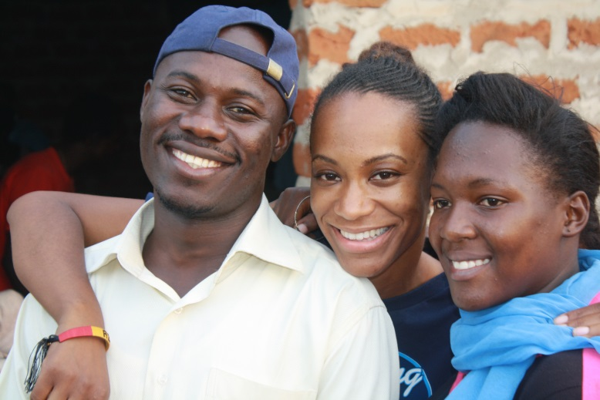If your trip involves traveling outside the country you are presently residing, please make sure your passport is valid and has at least 6 months to expiration from the travel date. Be sure to find out if you require a visa to the trip destination. Also, be aware that COVID restrictions and protocols have changed international travel. Please note that team members are responsible for finding out the local requirements, including visas for the country they are traveling to. If we can be of any assistance, please let us know early. Since overseas travel require a fair amount of physical exertion, it is recommended that you consult with your doctor before the trip. We also advise that you confirm from your doctor any required immunizations based on trip destination. Find out what travel medications or personal travel insurance you might need.

*Lasting memories and friendships are formed during the trip*

**Spiritual Preparation**

As part of your spiritual preparations, we advise that you begin right away to study the **Book of Philippians**. Every team member is advised to read through this before the trip. Set aside time to fast and pray as part of your preparations for the mission trip. Begin to do some research on your trip location and read good missionary biographies. Look for opportunities to attend a mission seminar, conference or other mission related programs. Inform your church leadership about your trip and request their prayer support. Step up your own individual prayer life immediately. Spend more personal time with God in worship. Pray for the mission trip and for our leadership team. Pray for other team members. Pray for the trip’s logistics, and pray for your own spiritual growth. Recruit prayer partners and arrange to pray with them regularly. Make good use of your social networks for prayer mobilization. Visit our prayer database at [**https://www.adonaipartners.org/prayer**](https://www.adonaipartners.org/prayer) for prayer highlights.

**Ministry Assignments**

Ministry assignments will be allocated taking into account your background as indicated in your trip registration or the interests you express during training, but please be aware that we cannot guarantee that everyone will get their preferences. Team Leaders have the final word on who does what. It will be helpful if you let us know your interests early enough.

### **C:\Users\Richard Erhiawarien\Desktop\Medical\DSC_0301.JPG**

*Team members Rev. Patrick Dogbe, Akua Boatema and others at the Pharmacy in Togo*

**Trip Cost**

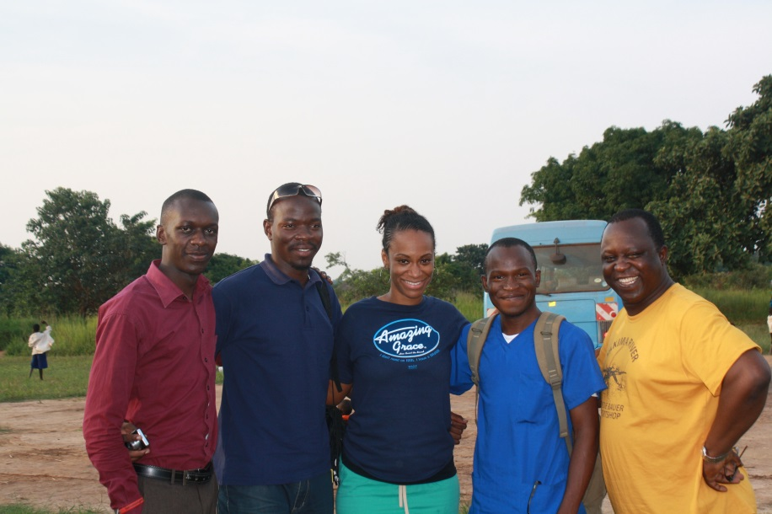Each team member traveling from the United States and Canada is required to raise a minimum of **$2,500** for the trip**.** This amount covers airfares from the East coast, local transportation, meals and accommodation. It also contributes towards program costs including medicines, food for the children and the supplies we use in the field. As can be expected, the bulk of this cost is taken up by airfare alone so to keep the travel cost low, it is necessary for us to purchase the tickets early. If a team member is unable to travel with the team this time, the amount raised by that individual will be set aside for their future trip if total amount they raised is at least $1,000; otherwise the amount raised goes to support the programs during the trip. Any amount raised by team members in excess of $2,500 goes towards the cost of on-going ministry and development programs in the field. Key programs in urgent need of funding are Discipleship, YoungLIFE, construction cost of the Adonai Chapel in Ghana and the school in Arut, Uganda.

*Doctors using their medical skills to proclaim Christ*

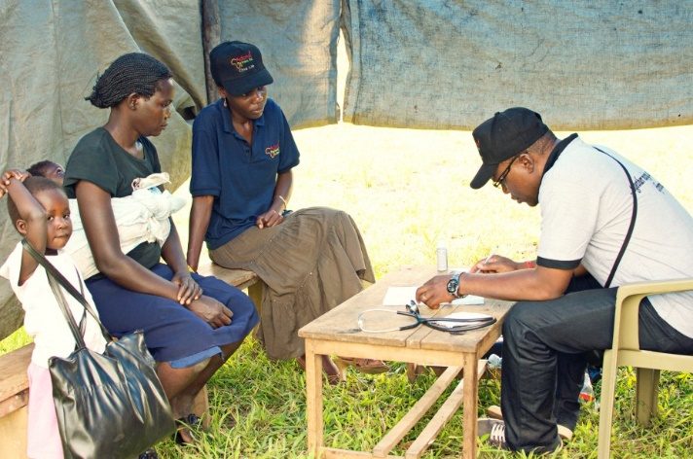**Team members traveling from locations other than the U.S.** have different fund raising targets. Please contact your country team leaders for the amount set for your country. We know that fund raising is one area where our faith is tested the most and grows as a result of the mission trip! Please pray for the fund raising efforts of all our team members. As stated earlier, we do our best to make sure no one who is really committed to going on the trip is denied the opportunity because of lack of funds. God is faithful.

*Dr. Austeen Akaehomen, Uganda*

**Ministry Programs**

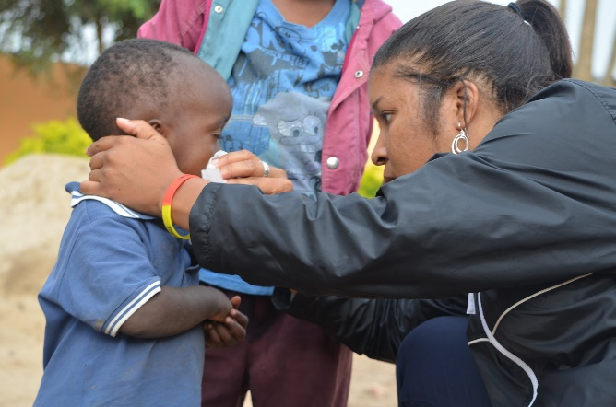

**It is important that you consider the ministry programs in your preparation for the trip. Let us know if you want an outline of ministry programs. Also, i**f you have a ministry tool or passion that you believe will be beneficial, please let us know. It is always a privilege to use the gifts God has given you to minister to others during the trip. These could include counseling, prayer and spiritual warfare, organizational effectiveness, leadership, drama ministry, worship, puppet ministry, joggling, information technology, business or other professional skills or anything else which brings glory to God and helps improve the lives of people and strengthen our local teams.

*Jennifer Duru helping a child in northern Uganda*

**Ten Team Commitments\*\***

Here are attitudes and commitments that we expect of everyone on the Adonai Partners team. Each commitment has a corresponding question we can all ask of ourselves to help nurture a culture within our ministry team that will enable everyone to grow and flourish!

* **Commitment to learning**. When I’m actively looking for opportunities to learn and grow in every situation, constructive criticism doesn’t come as an attack on me as a person but an answer to the question I’ve been asking all along. “How can I be a better person?”
* **Commitment to serving**. No matter what we find in our hands to do, whether teaching a child, counting medical pills, interpreting, serving food, leading worship, seeing a patient, extracting a tooth or anything in between, our first question to each other and to the people we serve should be 'how can I help you?’. I’m here to help, not to be served.
* **Commitment to excellence**. Excellence isn’t perfection, but it is my best, and my best means always getting better. It's an ever-changing dynamic in both our personal journey and the collective journey as a ministry team. It's about growth and maturity. Excellence should be a moving target of sorts. The quality of my life today should not be the same as the quality of what I was yesterday. It should be increasing and moving forward, not stagnating! At the end of each day we ask “Was today my best?”
* **Commitment to humility**. Philippians chapter 2 highlights this so well. It’s a ceaseless mission to place value on the people around me. God help me! “How can I demonstrate your value today?”
* **Commitment to devotion**. Am I exhibiting the fruit of the Spirit (Galatians 5:22) in my life more now than I was when I first heard of Adonai Partners? If so, then I am devoted to the right thing and the vision. Each day we ask “What fruit am I producing?”
* **Commitment to ownership**. Everyone in Adonai Partners is focused on transformation, not the mission trip. We bring solutions, not problems. We fix things that are broken. We actively look for needs and gaps and we fill them. We serve with an attitude that screams “If this was ‘my problem’ what would I do differently?” This is my Father’s work, I am not a hireling! I take ownership of the work Adonai Partners does, I’m not a tourist!
* **Commitment to others**. I don’t hold tightly to “my thing” but actively look for ways to include others on the journey. This is our mandate. We are one body, each with a part to play (1 Corinthians 12). We are part of the global Body of Christ committed to building His Kingdom. Evangelism is not an activity for the professional evangelist or pastors, it is a lifestyle of expectation as we constantly ask “Who else can I bring into the fold?” The harvest is ripe everywhere! We proclaim the Message of Christ by our lives and deeds but also with our words.
* 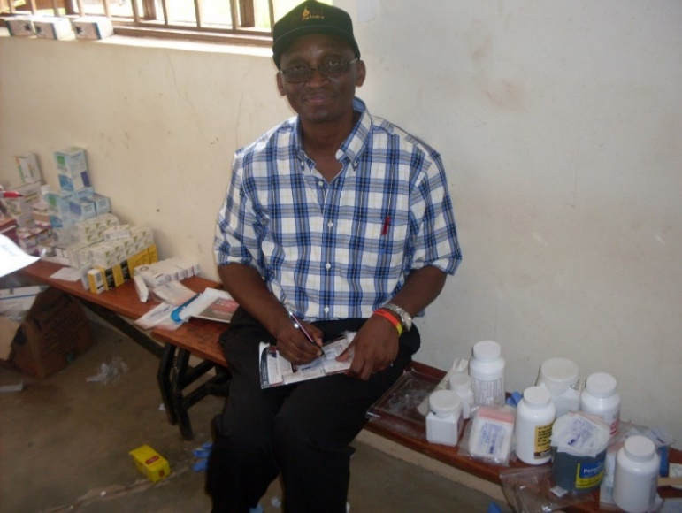**Commitment to unity**. Medical doctors, dentists, nurses, teachers, pastors, engineers, interpreters, pharmacists, singers, photographers, writers. We are all part of the team that God has brought together to be His hands extended to touch a world in need. We are better together! *No individuals are allowed on the team!* Our Lord Jesus values each one of us, and so must I, regardless of our differences. “Am I working in a silo?”

*Pastor Festus Okiomah helping in the pharmacy in Uganda*

* **Commitment to fun**. No explanation needed. Don’t forget to laugh! The mission trip is to be enjoyed, not endured! Take time to know other team members and share in their joy and struggles. “He will not crush the weakest reed or put out a flickering candle….And His name will be the hope of all the world.” Matt. 12:20-21 (NLT) “Do I take myself too seriously?”
* **Commitment to the Cause**. Family, friends, fun, and a team to be a part of are all great reasons to serve on the trip and beyond. But deep down inside I know that, if I was the only one here, I would still turn up. Why? Because I believe in the Cause of Christ. I believe in building what Jesus said He would build - His Church – across cultures and geography. (Matthew 16:18). Our commitment to His Cause, His Church and God’s global purpose in drawing the nations to worship Him is unchanging. “If I was the only one, would I still be here?”

**Mission Trip Reports**

At the end of the mission trip, **We expect you** to prepare a personal mission trip report to send to Adonai Partners. Therefore begin to prepare yourself for this often daunting task by keeping a journal of what the Lord is doing in your life as you prepare for the trip. Your report may be published in Adonai Partners website, newsletter or annual report.

**Staying Engaged!**

Even before you pick up your bags and get on the bus or plane for the mission trip, we want to remind you of the importance of staying engaged in missions long after the trip is over. Begin to think of your next mission trip!

**Give your Time…**

* If you are not able to GO on another mission trip soon, perhaps you can SEND. Encourage someone to GO. Support them through the process emotionally, spiritually and financially. Give of your time to consistently pray for Adonai Partners and for people on the mission field, missionaries. You can also host an **Oasis** gathering at your home. Oasis is an informal gathering of your friends, family and those you invite who are interested about missions.

**Give your Talent…**

* Preparing to take a team on a mission trip is a huge undertaking. Ask if there’s anything you can do to lighten the load by making telephone calls, sending out information, searching the web for inexpensive flights or any other administrative tasks that need to be done. If you have the ability of persuading and influencing others, then use that talent to talk about Adonai Partners and the work we do.

**Give your Resources…**

* Financially support the work of Adonai Partners. You can take part in the education sponsorship program and encourage others to join you. We plan to build an additional block of classrooms at the Adonai School in Arut, Uganda. An important project requiring significant financing are the Adonai mission bases we plan to build in our latest mission fields: Aseni and Nansoni.

God is working through Adonai Partners in bringing transformation to unreached and poor communities. Africans in Diaspora and those in Africa are working together to demonstrate God’s love in practical ways among people who are still waiting for the Message of Christ. African-Americans and non-Africans are investing in a continent with great potential to finish the global harvest. Our medical and dental outreaches and other development programs are tools and a bridge for church planting and discipleship of new believers. We invite you to find your place in the work God is doing through Adonai Partners. Welcome on board!

**Begin to imagine what God will do with your life during this mission trip for His excellent glory!**

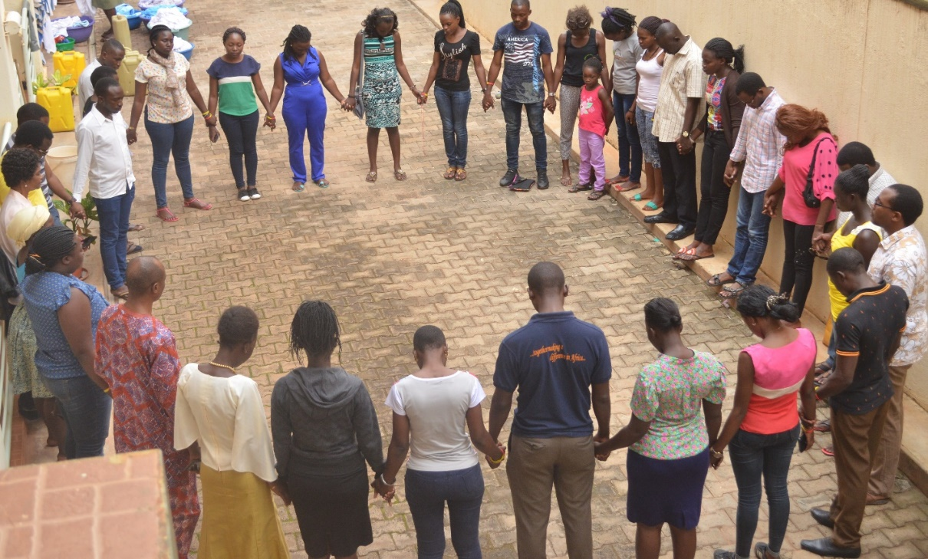

*Team members at a recent mission in Gulu, Uganda*



\_\_\_

+ adapted from Teen Mania Ministries

\* adapted from Chris Tiegreen

**\*\*** adapted from Brad Kohring, Hillsong Brisbane

**Adonai Partners, where love takes action!**

*C:\Users\Richard Erhiawarien\Documents\My Data\!Adonai Partners\Logo\Adonai Partners Logo\Logo\adonaipartners_logo.eps*



Adonai Partners **|** P O Box 4155, Silver Spring, MD 20914 USA

mail@adonaipartners.org **|** Toll Free: (800) 334-2775 **|** www.adonaipartners.org